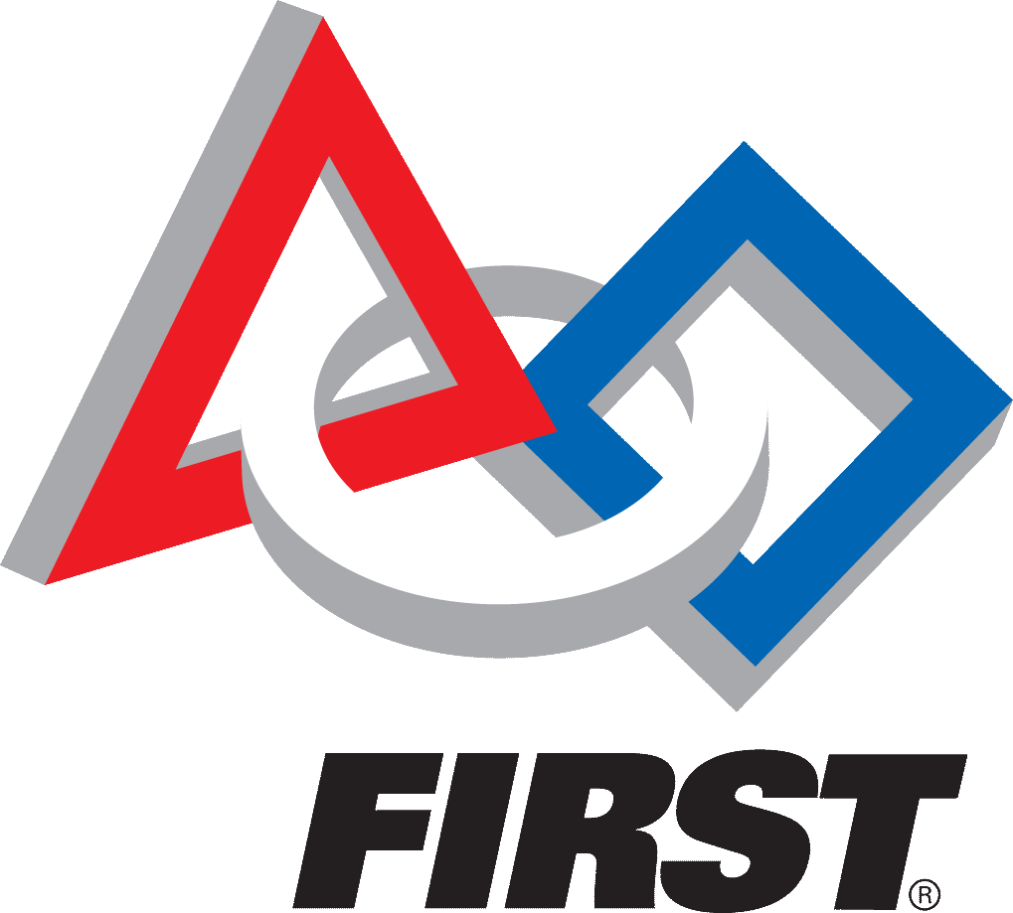
2018 San Diego FTC Achievement Scholarship
Counselor Recommendation Form

Section 1: Student Information
To the applicant: After completing the information in Section 1, please give this form to your high school counselor.

Name: | DOB: | Gender:  M ☐ F ☐
Address: | City, State, Zip
Section 2: Counselor Information
To the counselor: No recommendation letter is needed. Please complete this form and return via email -- along with a copy of the student’s transcript – to:
Robotics Inspiring Science and Engineering rise501c3@gmail.com
Subject line: Counselor Recommendation: Student’s Name
Must be received by February 17, 2018 for the student to eligible for the San Diego FTC Achievement Scholarship.

HS Graduation Date: Weighted GPA: Un-weighted GPA:
In comparison to other students at your school, this applicant’s course selection is:
Most demanding Demanding Average Less demanding than average

Has the applicant ever been placed on academic or disciplinary probation or suspension from secondary school? Yes No Unable to answer
Please indicate your perceptions of the applicant’s attributes in the following areas.
 | Excellent |  |  |  |  |  | Unsatisfactory |  |  | Not Observed
Academic Preparation | 9 | 8 | 7 | 6 | 4 | 5 | 3 | 2 | 1 | 0
Work ethic | 9 | 8 | 7 | 6 | 4 | 5 | 3 | 2 | 1 | 0
Initiative | 9 | 8 | 7 | 6 | 4 | 5 | 3 | 2 | 1 | 0
Leadership | 9 | 8 | 7 | 6 | 4 | 5 | 3 | 2 | 1 | 0
Concern for others | 9 | 8 | 7 | 6 | 4 | 5 | 3 | 2 | 1 | 0
Acceptance of diversity | 9 | 8 | 7 | 6 | 4 | 5 | 3 | 2 | 1 | 0
Integrity | 9 | 8 | 7 | 6 | 4 | 5 | 3 | 2 | 1 | 0
Service to others | 9 | 8 | 7 | 6 | 4 | 5 | 3 | 2 | 1 | 0

Counselor’s Name: Date:
Counselor Signature: Email:

