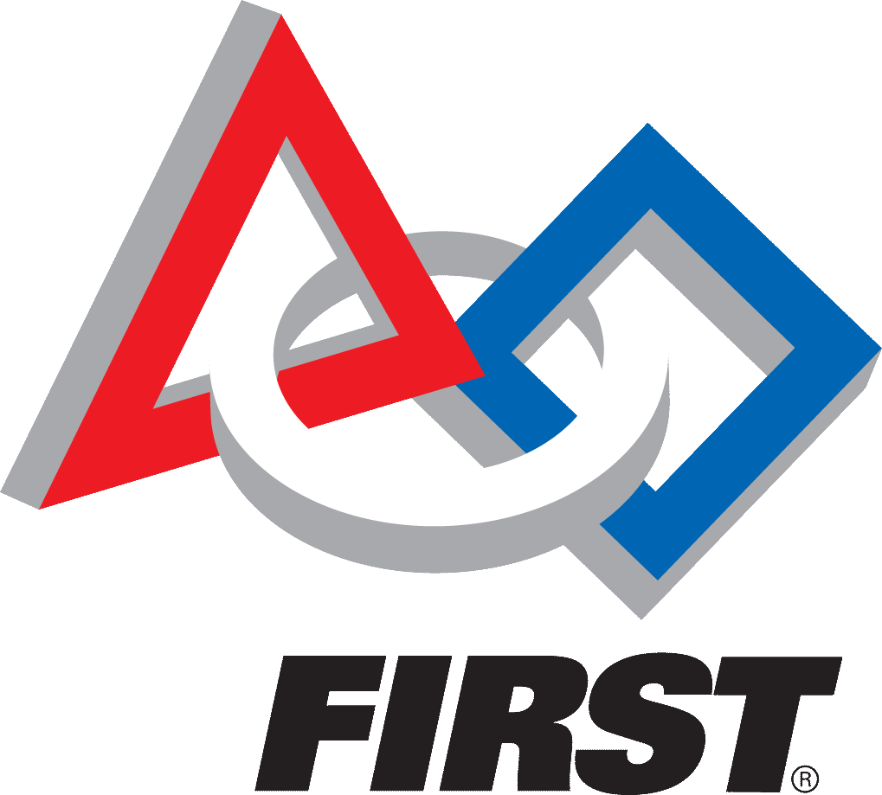
2018 San Diego FTC Achievement Scholarship
Coach’s Recommendation Form

Section 1: Student Information
To the applicant: After completing the information in Section 1, please give this form to your Coach.

Name: | DOB: | Gender:  M ☐ F ☐
Address: | City, State, Zip
Section 2: For the Robotics Coach -- Please complete this form and also provide a letter of recommendation discussing the applicant’s abilities and achievements. Letters that provide specific and detailed examples are the most helpful. Please send via email to:
Robotics Inspiring Science and Engineering rise501c3@gmail.com
Subject line: Coach Recommendation: Student’s Name
Must be received by February 17, 2018 for the student to eligible for the San Diego FTC Achievement Scholarship.

This applicant has held the following positions on your FIRST team: (mark all that apply)
Builder Programmer PTC /CAD design Mentor Captain
Drive Team Scout Publicity Outreach Coordinator
Outreach Participant

Compared to other students I have coached, this applicant’s overall contribution to the team is:
The best ever top 2 or 3 above average average or below

I have coached the applicant for: ________________ seasons.
I have coached robotics for: ________________ seasons.
Please indicate your perceptions of the applicant’s attributes in the following areas as they pertain to your FIRST Robotics Team. Circle your answer.
 | Excellent |  |  |  |  |  | Unsatisfactory |  |  | Not Observed
Technical Skills | 9 | 8 | 7 | 6 | 4 | 5 | 3 | 2 | 1 | 0
Work ethic | 9 | 8 | 7 | 6 | 4 | 5 | 3 | 2 | 1 | 0
Initiative | 9 | 8 | 7 | 6 | 4 | 5 | 3 | 2 | 1 | 0
Leadership | 9 | 8 | 7 | 6 | 4 | 5 | 3 | 2 | 1 | 0
Concern for others | 9 | 8 | 7 | 6 | 4 | 5 | 3 | 2 | 1 | 0
Acceptance of diversity | 9 | 8 | 7 | 6 | 4 | 5 | 3 | 2 | 1 | 0
Integrity | 9 | 8 | 7 | 6 | 4 | 5 | 3 | 2 | 1 | 0
Service to others | 9 | 8 | 7 | 6 | 4 | 5 | 3 | 2 | 1 | 0

Coach’s Name: Date:
Coach’s Signature: Email:

