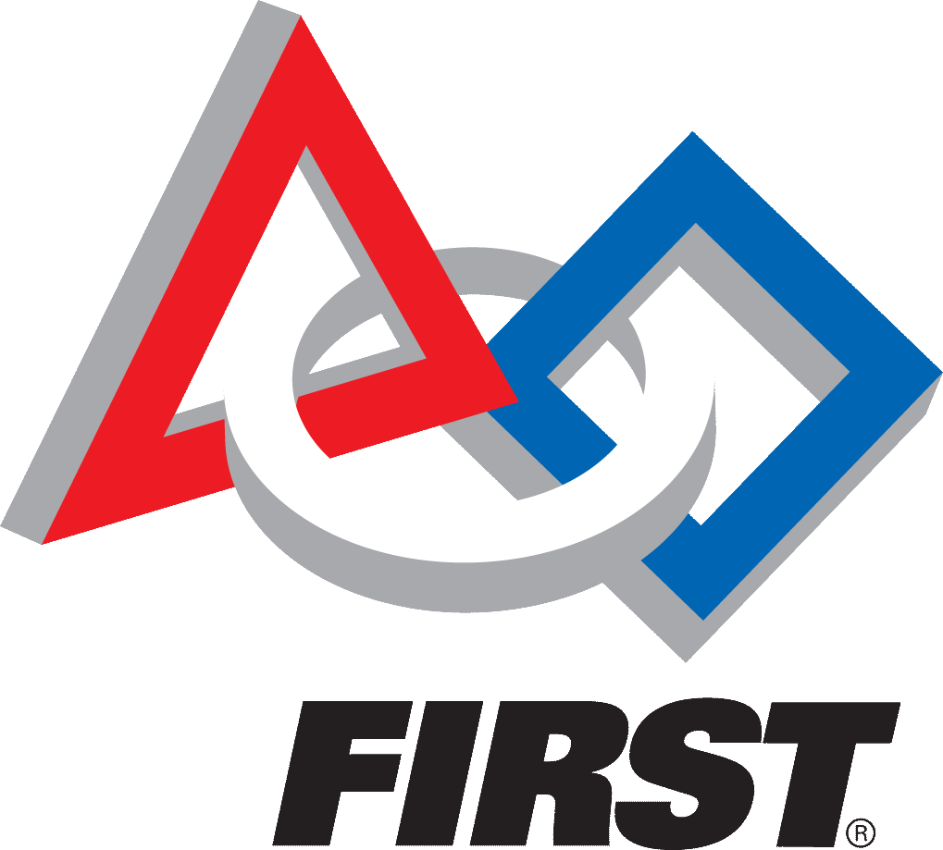
College-bound high school seniors currently active on an FTC team in the San Diego region are eligible to apply for this scholarship of up to $1,000. All application materials (including this application and two recommendation forms) must be submitted by February 23, 2019. Scholarship winners will be announced at the San Diego Regional FTC Championship on March 3, 2019.
2019 San Diego FTC Achievement Scholarship

Section 1: Student Information
Name:  Click here to enter text. | DOB:  Click here to enter text. | Gender:  M ☐ F ☐
Address:  Click here to enter text. | City, State, Zip  Click here to enter text.
Contact Phone Number:  Click here to enter text. | Contact Email:  Click here to enter text.
Parent’s Name (one parent only):  Click here to enter text. | Parent’s Contact Email:  Click here to enter text.

Section 2: Academic Information
High School:  Click here to enter text. | GPA:  Weighted: Click here to enter text.  Un-weighted: Click here to enter text.
Address:  Click here to enter text. | City, State, Zip  Click here to enter text.
Counselor’s Name:  Click here to enter text. | Counselor Email:  Click here to enter text.

Section 3: Future Goals
Anticipated HS Graduation Date:  Click here to enter text. | After Graduation I plan to: (check one)  ☐ Attend a 4 Year College  ☐ Attend a 2 Year College  ☐ Attend a Technical School
Anticipated Course of Study after high school:
Click here to enter text.

San Diego FTC Achievement Scholarship will be remitted directly to the winning students’ University, College or technical school upon proof of acceptance.

Section 4: FIRST (For Inspiration and Recognition of Science and Technology) Involvement
Team Number:  Click here to enter text. | Type of Team  ☐ FLL ☐ FTC ☐ FRC | Role:  ☐Participant ☐Mentor | Years Involved Click here to enter text.
Briefly describe your responsibilities on the team and any awards your team won:
Click here to enter text.

Team Number:  Click here to enter text. | Type of Team  ☐ FLL ☐ FTC ☐ FRC | Role:  ☐Participant ☐Mentor | Years Involved Click here to enter text.
Briefly describe your responsibilities on the team and any awards your team won:
Click here to enter text.

Team Number:  Click here to enter text. | Type of Team  ☐ FLL ☐ FTC ☐ FRC | Role:  ☐Participant ☐Mentor | Years Involved Click here to enter text.
Briefly describe your responsibilities on the team and any awards your team won:
Click here to enter text.

Team Number:  Click here to enter text. | Type of Team  ☐ FLL ☐ FTC ☐ FRC | Role:  ☐Participant ☐Mentor | Years Involved Click here to enter text.
Briefly describe your responsibilities on the team and any awards your team won:
Click here to enter text.

Section 5: Extra Curricular, Volunteer, Work Experience (please limit to the 5 most significant to you). In lieu of completing this section, you may attach a resume.
Activity | 9th Grade |  | 10th Grade |  | 11th Grade |  | 12th Grade
 | Hrs./Wk. | Wks./Yr. | Hrs./Wk. | Wks./Yr. | Hrs./Wk. | Wks./Yr. | Hrs./Wk. | Wks./Yr.
Click here to enter text. | Click here to enter text. | Click here to enter text. | Click here to enter text. | Click here to enter text. | Click here to enter text. | Click here to enter text. | Click here to enter text. | Click here to enter text.
Click here to enter text. | Click here to enter text. | Click here to enter text. | Click here to enter text. | Click here to enter text. | Click here to enter text. | Click here to enter text. | Click here to enter text. | Click here to enter text.
Click here to enter text. | Click here to enter text. | Click here to enter text. | Click here to enter text. | Click here to enter text. | Click here to enter text. | Click here to enter text. | Click here to enter text. | Click here to enter text.
Click here to enter text. | Click here to enter text. | Click here to enter text. | Click here to enter text. | Click here to enter text. | Click here to enter text. | Click here to enter text. | Click here to enter text. | Click here to enter text.
Click here to enter text. | Click here to enter text. | Click here to enter text. | Click here to enter text. | Click here to enter text. | Click here to enter text. | Click here to enter text. | Click here to enter text. | Click here to enter text.
Section 6: Essay
Word count: approximately 500 words.

Topic: What are your plans for the future and how has your involvement in FIRST influenced your plans?

Application Check List
Please submit the following to be considered for the San Diego FTC Achievement Scholarship:

☐ Completed Application Form (sections 1 – 5)

☐ Essay (section 6)

☐ Letter of recommendation and evaluation form from your FTC coach

☐ Counselor Evaluation form (optional but recommended)

****San Diego FTC Achievement Scholarship Applications are due February 23, 2019 ***

Please send your completed application (and have your coach and counselor send their completed evaluations/recommendation) as follows:

Via Email:
Scan your application and email to Robotics Inspiring Science and Engineering at:
rise501c3@gmail.com
Subject line: Scholarship Application: Your Name.

Please allow 48 hours for responses to this email address as it staffed by volunteers!

